Inv-fin tø
US 1
2.1 1776 compound interest til idag
a) 3.3%
$${\left(1.033\right)}^{2024-1776}≈3139,639$$
b) 6.6%
$${\left(1.066\right)}^{2024-1776}≈7652208$$
2.3 effektive renter
a) 3% månedlig
$${\left(1+\frac{0.03}{12}\right)}^{12}-1≈0,03041596$$
b) 18% månedlig
$${\left(1+\frac{0.18}{12}\right)}^{12}-1≈0,1956182$$
c) 18% kvartal
$${\left(1+\frac{0.18}{4}\right)}^{4}-1≈0,1925186$$
2.5 10 mil lottery betaling af 500k årligt over 20 år find npv ved 10% rente
$$\sum_{i=0}^{19}{\frac{500}{{1.1}^{i}}}=4682.46$$
Altså 4 mil 682k er den egentlige værdi af lotteri premien
2.7
$$NPV\left(\left[-1,0,3\right]\right)=\frac{3}{{\left(1.1\right)}^{2}}-1$$
$$NPV\left(\left[-1,0,0,x\right]\right)=\frac{x}{{1.1}^{3}}-1$$
$$NPV\left(\left[-1,0,0,x\right]\right)≤NPV\left(\left[-1,0,3\right]\right)$$
$$\frac{x}{{1.1}^{3}}≤\frac{3}{{\left(1.1\right)}^{2}}$$
$$x≤3.3$$
2.9 vi kigger udelukkende på taget fast pris
Per the law of one price må prisen på at have taget I de 5 første år have samme værdi som det vi spare i uendelighed ved at have taget frem for ikke at have det altså
$$p_{tag}+20k\sum_{n=0}^{∞}{\frac{1}{{\left(1.05\right)}^{20·n+5}}}=20k\sum_{n=0}^{∞}{\frac{1}{{\left(1.05\right)}^{20·n}}}$$
$$p_{tag}=20k·\left(1-\frac{1}{{1.05}^{5}}\right)·\left(\frac{1}{1-\frac{1}{{\left(1.05\right)}^{20}}}\right)=6948,168$$
Oplagt opgave
- Udregn diskonteringsfaktoren
$$B=\left(\begin{matrix}107 & 0 & 0 \\ 9 & 109 & 0 \\ 10 & 10 & 110\end{matrix}\right)$$
$$P=\left(\begin{aligned}100 \\ 103.62 \\ 107.87\end{aligned}\right)$$
Starter med at se at B er invertibel altså er markedet arbitragefrit og komplett
$${\left(\begin{matrix}107 & 0 & 0 \\ 9 & 109 & 0 \\ 10 & 10 & 110\end{matrix}\right)}^{-1}\left(\begin{aligned}100 \\ 103.62 \\ 107.87\end{aligned}\right)≈\left(\begin{matrix}0,9345794 \\ 0,8734751 \\ 0,8162678\end{matrix}\right)=d$$
- Er markedet arbitragefrit?
Ja markedet er arbitragefrit da der eksisterer en vektor d der løser systemet
$$P=B·d$$
- Er markedet komplet?
B er invertibel så ja specielt er T=rank(B) så ja markedet er komplet
Der er ligeså mange lineært uafh produkter som der er perioder

$$θ=\left(\begin{matrix}59 & 54,5 & 0\end{matrix}\right){\left(\begin{matrix}107 & 0 & 0 \\ 9 & 109 & 0 \\ 10 & 10 & 110\end{matrix}\right)}^{-1}=\left(\begin{matrix}0,5093457943925234 & 0,5 & 0\end{matrix}\right)=\left(\begin{matrix}\frac{54.5}{107} & 0.5 & 0\end{matrix}\right)$$
$$transpose\left(\left(\begin{aligned}\frac{54.5}{107} \\ 0.5 \\ 0\end{aligned}\right)\right)\left(\begin{aligned}100 \\ 103.62 \\ 107.87\end{aligned}\right)≈102,7446$$
Ja der er arbitrage køb 1 pf4 sælg $\left(\begin{aligned}\frac{54.5}{107} \\ 0.5 \\ 0\end{aligned}\right)$ giver
$$\left(\begin{aligned}\frac{54.5}{107} \\ 0.5 \\ 0 \\ -1\end{aligned}\right)$$
Koster - 2.7 men giver 0 i cashflows altså arbitrage
US 2
3.1
Annuity monthly payments, 7 years 7% interest value 25.000 find monthly payments
$$25000=\frac{a·12}{0.07}·\left(1-\frac{1}{{\left(1+\frac{0.07}{12}\right)}^{12·7}}\right)$$
$⇕$ Ligningen løses for a vha. WordMat.
$$a=\frac{18860500000}{49985821}≈377,317$$
3.3 assuming independence P2 skal læses som chancen for at han når at blive 90,91 så chancen for at han når at blive 101 er 4%
$$A=\left(\begin{aligned}90 \\ 91 \\ 92 \\ 93 \\ 94 \\ 95 \\ 96 \\ 97 \\ 98 \\ 99 \\ 100 \\ 101\end{aligned}\right), P=\left(\begin{aligned}0.07 \\ 0.08 \\ 0.09 \\ 0.1 \\ 0.1 \\ 0.1 \\ 0.1 \\ 0.1 \\ 0.1 \\ 0.07 \\ 0.05 \\ 0.04\end{aligned}\right), d=\left(\begin{aligned}0 \\ (\frac{1}{1.07}) \\ {\left(\frac{1}{1.07}\right)}^{2} \\ {\left(\frac{1}{1.07}\right)}^{3} \\ {\left(\frac{1}{1.07}\right)}^{4} \\ {\left(\frac{1}{1.07}\right)}^{5} \\ {\left(\frac{1}{1.07}\right)}^{6} \\ {\left(\frac{1}{1.07}\right)}^{7} \\ {\left(\frac{1}{1.07}\right)}^{8} \\ {\left(\frac{1}{1.07}\right)}^{9} \\ {\left(\frac{1}{1.07}\right)}^{10} \\ {\left(\frac{1}{1.07}\right)}^{11}\end{aligned}\right), P_{2}=\left(\begin{aligned}1 \\ 0.93 \\ 0.85 \\ 0.76 \\ 0.66 \\ 0.56 \\ 0.46 \\ 0.36 \\ 0.26 \\ 0.16 \\ 0.09 \\ 0.04\end{aligned}\right)$$
$$transpose\left(\left(\begin{aligned}0.07 \\ 0.08 \\ 0.09 \\ 0.1 \\ 0.1 \\ 0.1 \\ 0.1 \\ 0.1 \\ 0.1 \\ 0.07 \\ 0.05 \\ 0.04\end{aligned}\right)\right)\left(\begin{aligned}90 \\ 91 \\ 92 \\ 93 \\ 94 \\ 95 \\ 96 \\ 97 \\ 98 \\ 99 \\ 100 \\ 101\end{aligned}\right)≈95,13$$
His average live is exactly the expected value
$$P_{n}=\frac{10k}{0.08}·\left(1-\frac{1}{{\left(1+0.08\right)}^{5.13}}\right)=40,77401·k$$
$$transpose\left(\left(\begin{aligned}0.07 \\ 0.08 \\ 0.09 \\ 0.1 \\ 0.1 \\ 0.1 \\ 0.1 \\ 0.1 \\ 0.1 \\ 0.07 \\ 0.05 \\ 0.04\end{aligned}\right)\right)\left(\begin{aligned}p_{1} \\ … \\ p_{11}\end{aligned}\right)=transpose\left(\left(\begin{aligned}0.07 \\ 0.08 \\ 0.09 \\ 0.1 \\ 0.1 \\ 0.1 \\ 0.1 \\ 0.1 \\ 0.1 \\ 0.07 \\ 0.05 \\ 0.04\end{aligned}\right)\right)\left(\begin{aligned}0 \\ \frac{10k}{0.08}·\left(1-\frac{1}{{\left(1+0.08\right)}^{1}}\right) \\ \frac{10k}{0.08}·\left(1-\frac{1}{{\left(1+0.08\right)}^{2}}\right) \\ \frac{10k}{0.08}·\left(1-\frac{1}{{\left(1+0.08\right)}^{3}}\right) \\ \frac{10k}{0.08}·\left(1-\frac{1}{{\left(1+0.08\right)}^{4}}\right) \\ \frac{10k}{0.08}·\left(1-\frac{1}{{\left(1+0.08\right)}^{5}}\right) \\ \frac{10k}{0.08}·\left(1-\frac{1}{{\left(1+0.08\right)}^{6}}\right) \\ \frac{10k}{0.08}·\left(1-\frac{1}{{\left(1+0.08\right)}^{7}}\right) \\ \frac{10k}{0.08}·\left(1-\frac{1}{{\left(1+0.08\right)}^{8}}\right) \\ \frac{10k}{0.08}·\left(1-\frac{1}{{\left(1+0.08\right)}^{9}}\right) \\ \frac{10k}{0.08}·\left(1-\frac{1}{{\left(1+0.08\right)}^{10}}\right) \\ \frac{10k}{0.08}·\left(1-\frac{1}{{\left(1+0.08\right)}^{11}}\right)\end{aligned}\right)=38,38695·k$$
$$=38387$$

3.5

$$\left(\sum_{n=1}^{20}{100·\frac{0.1}{{\left(1+0.1\right)}^{n}}}+\frac{100}{{\left(1+0.1\right)}^{20}}\right)·1.05≈105$$
$$NPV>105$$
$$\sum_{n=1}^{15}{100·\frac{0.1}{{\left(1+y\right)}^{n}}}+\frac{100}{{\left(1+y\right)}^{15}}=105=\frac{10}{y+1}+\frac{10}{{\left(y+1\right)}^{2}}+\frac{10}{{\left(y+1\right)}^{3}}+\frac{10}{{\left(y+1\right)}^{4}}+\frac{10}{{\left(y+1\right)}^{5}}+\frac{10}{{\left(y+1\right)}^{6}}+\frac{10}{{\left(y+1\right)}^{7}}+\frac{10}{{\left(y+1\right)}^{8}}+\frac{10}{{\left(y+1\right)}^{9}}+\frac{10}{{\left(y+1\right)}^{10}}+\frac{10}{{\left(y+1\right)}^{11}}+\frac{10}{{\left(y+1\right)}^{12}}+\frac{10}{{\left(y+1\right)}^{13}}+\frac{10}{{\left(y+1\right)}^{14}}+\frac{110}{{\left(y+1\right)}^{15}}=105$$
$$\frac{10}{y+1}+\frac{10}{{\left(y+1\right)}^{2}}+\frac{10}{{\left(y+1\right)}^{3}}+\frac{10}{{\left(y+1\right)}^{4}}+\frac{10}{{\left(y+1\right)}^{5}}+\frac{10}{{\left(y+1\right)}^{6}}+\frac{10}{{\left(y+1\right)}^{7}}+\frac{10}{{\left(y+1\right)}^{8}}+\frac{10}{{\left(y+1\right)}^{9}}+\frac{10}{{\left(y+1\right)}^{10}}+\frac{10}{{\left(y+1\right)}^{11}}+\frac{10}{{\left(y+1\right)}^{12}}+\frac{10}{{\left(y+1\right)}^{13}}+\frac{10}{{\left(y+1\right)}^{14}}+\frac{110}{{\left(y+1\right)}^{15}}>105$$
$⇕$ Uligheden løses for y vha. .
$$y>-1 ∧ y<0,09366232645133443$$
3.9 givet 1 årlig betaling
$$P=\left(\sum_{n=1}^{18}{100·\frac{0.08}{{\left(1+0.09\right)}^{n}}}+\frac{100}{{\left(1+0.09\right)}^{18}}\right)≈91,24437$$
3.10 fucking halvårig(bogen giver svarende efter halvårig udbetaling
$$P=\left(\sum_{n=1}^{20}{100·\frac{0.04}{{\left(1+\frac{0.1}{2}\right)}^{n}}}+\frac{100}{{\left(1+\frac{0.1}{2}\right)}^{10·2}}\right)≈87,53779$$
$$D_{mod}=\frac{1}{87,53779}·\frac{1}{1+\frac{0.1}{2}}·\left(\sum_{n=1}^{20}{\frac{n}{2}·\frac{\frac{8}{2}}{{\left(1+\frac{0.1}{2}\right)}^{n}}}+10·\frac{100}{{\left(1+\frac{0.1}{2}\right)}^{20}}\right)≈6,514637$$
$$D_{mac}=6,514637·\left(1.05\right)≈6,840369$$
$$D_{mac}=\frac{1+0.1}{0.1}-\frac{1+0.1+10·\left(0.08-0.10\right)}{0.08·\left({1.1}^{10}-1\right)+0.1}≈7,043946$$

3.11
$$P\left(r\right)=\sum_{n=1}^{∞}{\frac{a}{{\left(1+r\right)}^{n}}}=\frac{a}{r}$$
$$D_{mod}=-\frac{1}{p}·\frac{dP}{dr}=-\frac{1}{p}·\left(-\frac{a}{r^{2}}\right)=\frac{1}{r}$$
$$D_{mac}=D_{mod}·\left(1+r\right)=\frac{1+r}{r}$$
3.12
$$B=\left(\begin{matrix}100 & 100 & 1100 \\ 50 & 50 & 1050 \\ 0 & 0 & 1000 \\ 1000 & 0 & 0\end{matrix}\right) ,d=\left(\begin{aligned}1/(1.15) \\ 1/{1.15}^{2} \\ 1/{1.15}^{3}\end{aligned}\right)$$
$$\left(\begin{matrix}100 & 100 & 1100 \\ 50 & 50 & 1050 \\ 0 & 0 & 1000 \\ 1000 & 0 & 0\end{matrix}\right)\left(\begin{aligned}\frac{1}{1.15} \\ \frac{1}{{1.15}^{2}} \\ \frac{1}{{1.15}^{3}}\end{aligned}\right) ≈\left(\begin{matrix}885,8387 \\ 771,6775 \\ 657,5162 \\ 869,5652\end{matrix}\right)$$
$$\left(\begin{matrix}100 & 100 & 1100 \\ 50 & 50 & 1050 \\ 0 & 0 & 1000 \\ 1000 & 0 & 0\end{matrix}\right)\left(\begin{aligned}\frac{1}{1.15} \\ \frac{2}{{1.15}^{2}} \\ \frac{3}{{1.15}^{3}}\end{aligned}\right)≈\left(\begin{matrix}2407,989 \\ 2190,269 \\ 1972,549 \\ 869,5652\end{matrix}\right)$$
$$D_{mac}=\left(\begin{matrix}\frac{2407,989}{885,8387} \\ \frac{2190,269}{771,6775} \\ \frac{1972,549}{657,5162} \\ \frac{869,5652}{869,5652}\end{matrix}\right)≈\left(\begin{matrix}2,718315 \\ 2,838322 \\ 3,000001 \\ 1\end{matrix}\right)$$
$$D_{mod}=\frac{D_{mac}}{1.15}=\frac{1}{1.15}\left(\begin{matrix}2,718315 \\ 2,838322 \\ 3,000001 \\ 1\end{matrix}\right)≈\left(\begin{matrix}2,363752 \\ 2,468106 \\ 2,608697 \\ 0,8695652\end{matrix}\right)$$
Bond C is most sensitive to yield changes since the modified duration is the highest this makes sence since it’s a 0 cupon bond with the longest maturity
We have a new bond with $B_{e}={\left(\begin{aligned}0 \\ 2000 \\ 0\end{aligned}\right)}^{T}$
Assuming the yield must be 15%
$$P\left(0.15\right)=\frac{2000}{{\left(1.15\right)}^{2}}≈1512,287$$
$$D_{e}=2$$
We must have $V_{a}+V_{b}+V_{c}+V_{d}=1512,287$
$$D_{e}=\frac{V_{a}·D_{a}+V_{b}·D_{b}+V_{c}·D_{c}+V_{d}·D_{d}}{1512,287}$$
We choose to use $B_{c} , B_{D}$
$$C+D=1512,287$$
$$2·1512,287=3·C+D$$
$⇕$ Ligningssystemet løses for C,D vha. 's 'Løs Ligninger' funktion,
$$C=\frac{163327}{216}=756,1435;D=\frac{163327}{216}=756,1435$$
No there isent a way to make it cheaper
$$2,838322·B+3·C=2·1512,287$$
$$B+C=1512,287$$
$⇕$ Ligningssystemet løses for B,C vha. 's 'Løs Ligninger' funktion,
$$B=\frac{40015115}{4278}≈9353,697$$
$$C=-\left(\frac{603819919}{77004}\right)≈-7841,41$$

3.13
$$\frac{dP}{dλ}=-D·P=\sum_{k=0}^{n}{t_{k}e^{-λk}·c_{k}}$$
3.14
When duration approaches infinity the properties must approach that of a perpetuity
Thus per 3.11 we must have
$$P\left(λ\right)=\frac{c·F·m}{r}$$
$$D_{mac}=D_{mod}·\left(1+\frac{λ}{m}\right)=\left(1+\frac{λ}{m}\right)·-\frac{λ}{c·F·m}·\frac{\left(-c·F·m\right)}{λ^{2}}=\frac{1+\frac{λ}{m}}{λ}$$
We also have another formula y is yield per period m is periods per year n Is years and c is cupon rate
$$D=\frac{1+y}{m·y}-\frac{1+y+n\left(c-y\right)}{mc\left({\left(1+y\right)}^{n}-1\right)+m·y}→\frac{1+y}{m·y}$$
For $n→∞$
$$y=\frac{λ}{m}$$
Thus
$$D→\frac{1+\frac{λ}{m}}{λ}$$

3.15
$$P\left(λ\right)=F·e^{-λT}$$
$$\frac{dP}{dλ}=-T·F·e^{-λT}$$
$$\frac{d^{2}P}{dλ^{2}}=T^{2}·F·e^{-λT}$$
$$C=\frac{1}{p}·\frac{d^{2}P}{dP^{2}}=T^{2}$$

Us 3
4.1
$$s_{1}=6.3\%, s_{2}=6.9\%$$
Find $f_{1,2}$
$$\left(1+0.063\right)·\left(1+x\right)={\left(1+0.069\right)}^{2}$$
$⇕$ Ligningen løses for x vha. WordMat.
$$x=\frac{79761}{1063000}≈0,07503387=7.5\%$$
4.3
You could calculate spot rates but id rather not
$$b_{2}-\frac{7}{9}·b_{1}=\left(\begin{aligned}0 \\ 0 \\ 0 \\ 0 \\ 107-\frac{7}{9}·109\end{aligned}\right)=\left(\begin{matrix}0 \\ 0 \\ 0 \\ 0 \\ \frac{200}{9}\end{matrix}\right)≈\left(\begin{matrix}0 \\ 0 \\ 0 \\ 0 \\ 22,22222\end{matrix}\right)$$
$$\frac{9}{2}·\left(\begin{matrix}0 \\ 0 \\ 0 \\ 0 \\ \frac{200}{9}\end{matrix}\right)=\left(\begin{matrix}0 \\ 0 \\ 0 \\ 0 \\ 100\end{matrix}\right)$$
$$b_{0}=\frac{9}{2}·b_{2}-\frac{7}{2}b_{1}$$
$$\frac{9}{2}p_{1}-\frac{7}{2}p_{2}=\frac{9}{2}·93.2-\frac{7}{2}·101≈65,9$$
Thus we can find $s_{5}$
$$\frac{100}{{\left(1+x\right)}^{5}}<65.9$$
$⇕$ Uligheden løses for x vha. .
$$x<-1 ∨ x>0,08698341994555803$$
$$s_{5}=8.7\%$$
4.5
$s\left(t\right)$ is given such that $PV_{t}\left(1\right)=e^{-s\left(t\right)·t}=d_{t}$
$$e^{s\left(t_{2}\right)t_{2}}=e^{s\left(t_{1}\right)t_{1}}·e^{f_{t_{1},t_{2}}·\left(t_{2}-t_{2}\right)}$$
$$\frac{s\left(t_{2}\right)·t_{2}-s\left(t_{1}\right)·t_{1}}{t_{2}-t_{1}}=f_{t_{1},t_{2}}$$
Let $r\left(t\right)=\lim_{t_{2}→t}{f(t,t_{2})}$
Vis $r\left(t\right)=s\left(t\right)+s'(t)$

$$\lim_{t_{2}→t}{f\left(t,t_{2}\right)}$$
$$f\left(t_{1},t_{2}\right)=\frac{s\left(t_{2}\right)·t_{2}-s\left(t\right)·t}{t_{2}-t}=s\left(t_{2}\right)·\frac{t_{2}-t}{t_{2}-t}+t·\frac{s\left(t_{2}\right)-s\left(t_{1}\right)}{t_{2}-t}$$

$s$ antages differentiable da har vi
$r\left(t\right)=\lim_{t_{2}→t}{f(t,t_{2})}=s\left(t\right)+t·s'(t)$
$find an x(t)$ such that
$$\frac{dx(t)}{dt}=r\left(t\right)·x(t)$$
Let $x\left(t\right)=e^{\int_{0}^{t}{r\left(x\right)}dx}·x_{0}=e^{s\left(t\right)·t}·x_{0}$
$$\int_{0}^{t}{r\left(x\right)}dx=\int_{0}^{t}{s\left(x\right)+t·s'(x) }dx=\int_{0}^{t}{s\left(x\right)}dx+s\left(t\right)·t-\int_{0}^{t}{s\left(x\right)}dx=s\left(t\right)·t$$
Da har vi per kædereglen og analysens fundamentalsætning
$$\frac{dx(t)}{dt}=r\left(t\right)·e^{s\left(t\right)·t}·x_{0}$$
4.6
Se $d_{i,k}=d_{i,j}·d_{j,k}$
$$d_{0,1}=0.95,d_{1,2}=0.94,d_{2,3}=0.932, d_{3,4}=0.925, d_{4,5}=0.919, d_{5,6}=0.913$$
$$d_{0,2}=0.95·0.94≈0,893$$
$$d_{0,3}=0,893·0.932=0,832276$$
$$d_{0,4}=0,832276·0.925=0,7698553$$
$$d_{0,5}=0,7698553·0.919≈0,707497$$
$$d_{0,6}=0,707497·0.913≈0,6459448$$
4.9
$$s\left(k\right)=r$$
$${\left(1+s\left(k\right)\right)}^{k}·{\left(1+f\left(k,i\right)\right)}^{i-k}={\left(1+s\left(i\right)\right)}^{i}$$
$${\left(1+r\right)}^{k}·{\left(1+f\left(k,i\right)\right)}^{i-k}={\left(1+r\right)}^{i}$$
$$f\left(k,i\right)=r$$
4.14 opdelt huslån
$$M\left(k\right)=\left(1+r\right)·M\left(k-1\right)-B$$
$$M\left(k\right)={\left(1+r\right)}^{k}M-\frac{{\left(1+r\right)}^{k}-1}{r}B$$
Antag lånet har n perioder og B er sat så $M\left(n\right)=0$ da har vi
$$B=\frac{r{\left(1+r\right)}^{n}M}{{\left(1+r\right)}^{n}-1}$$
$$I\left(k\right)=r·M\left(k-1\right)$$
$$P\left(k\right)=B-rM\left(k-1\right)$$
- Find PV af principal payments som funk af B,m,n,r
$$V=\sum_{k=1}^{n}{\frac{P\left(k\right)}{{\left(1+r\right)}^{k}}}$$
$$\sum_{k=1}^{n}{\frac{P\left(k\right)}{{\left(1+r\right)}^{k}}}=\sum_{k=1}^{n}{\frac{B-rM\left(k-1\right)}{{\left(1+r\right)}^{k}}}=\sum_{k=1}^{n}{\frac{B-r·\left({\left(1+r\right)}^{k-1}M-\frac{{\left(1+r\right)}^{k-1}-1}{r}B\right)}{{\left(1+r\right)}^{k}}}$$
$$=\sum_{k=1}^{n}{\frac{B-B-M·{\left(1+r\right)}^{k-1}·r+{\left(1+r\right)}^{k-1}·B}{{\left(1+r\right)}^{k}}}=\sum_{k=1}^{n}{\frac{-M·{\left(1+r\right)}^{k-1}·r+{\left(1+r\right)}^{k-1}·B}{{\left(1+r\right)}^{k}}}=n·\frac{B-M·r}{1+r}$$
- Fjern B
$$=n·\frac{B}{1+r}-n·\frac{M·r}{1+r}=n·\frac{r{\left(1+r\right)}^{n}M}{{\left(1+r\right)}^{n}-1}·\frac{1}{1+r}-n·\frac{M·r}{1+r}=n·M·r·\frac{1}{{\left(1+r\right)}^{n}-1}$$
- Find pv af W
$$I\left(k\right)=r·M\left(k-1\right)=r·\left({\left(1+r\right)}^{k-1}M-\frac{{\left(1+r\right)}^{k-1}-1}{r}B\right)$$
$$=\left(Mr-B\right){\left(1+r\right)}^{k-1}+B$$
$$\sum_{k=1}^{n}{\frac{\left(Mr-B\right){\left(1+r\right)}^{k-1}+B}{{\left(1+r\right)}^{k}}}=\sum_{k=1}^{n}{\frac{Mr-B}{1+r}}+\frac{B}{{\left(1+r\right)}^{k}}$$
$$=n·\frac{Mr-B}{1+r}+B\sum_{k=1}^{n}{\frac{1}{{\left(1+r\right)}^{k}}}=n·\frac{Mr-B}{1+r}+\frac{r{\left(1+r\right)}^{n}M}{{\left(1+r\right)}^{n}-1}·\frac{\left({\left(1+r\right)}^{n}-1\right)}{r·{\left(1+r\right)}^{n}}$$
$$=M-V$$
- 2
$$n·M·r·\frac{1}{{\left(1+r\right)}^{n}-1}→0 for n→∞$$
- Har lidt svært ved at læse og synes det bliver nedern at finde ud af hvilke bliver til
P er stigende i k og I er faldende i k da måvarigheden af den der er stigende i k da det er vægtningen af hvornår der bliver betalt
Da er varigheden for p(k) højere

Nelson siegel

Us 4
6.2
$$X,Y\sim iid terninger$$
Find middelværdi og varians
$$E\left(X·Y\right)=E\left(X\right)·E\left(Y\right)={3.5}^{2}=12,25$$
$$VAR\left(X·Y\right)=E\left(X^{2}·Y^{2}\right)-E{\left(X·Y\right)}^{2}$$
$$=E\left(X^{2}\right)·E\left(Y^{2}\right)-E{\left(X\right)}^{2}·E{\left(Y\right)}^{2}$$

$$E\left(X^{2}\right)=\sum_{k=1}^{6}{\frac{k^{2}}{6}}=\frac{91}{6}≈15,16667$$
$$\sum_{k=1}^{6}{\frac{k}{6}}=\frac{7}{2}=3,5$$
$$Var\left(X·Y\right)={\left(\frac{91}{6}\right)}^{2}-{\left(\frac{7}{2}\right)}^{4}=\frac{11515}{144}≈79,96528$$
6.3
$$ρ_{a,b}=\frac{cov\left(a,b\right)}{\sqrt{var\left(a\right)}·\sqrt{var\left(b\right)}}$$
$$ρ_{a,b}=0.1, var\left(a\right)={0.15}^{2}=0,0225, var\left(b\right)={0.3}^{2}=0,09$$
Find den varians minimerende portefølje
$$0.1=\frac{c}{0.15·0.3}$$
$⇕$ Ligningen løses for c vha. WordMat.
$$cov(a,b)=\frac{9}{2000}$$
Tager formel fra næste opgave
$$a=\frac{var\left(B\right)-cov\left(A,B\right)}{var\left(A\right)+var\left(B\right)-2cov\left(A,B\right)}=\frac{0,09-\frac{9}{2000}}{0.0225+0.09-\frac{9}{1000}} ≈0,826087$$
$$\left(\begin{aligned}0,826 \\ 0.174\end{aligned}\right)$$
$$var={0,826}^{2}·0,0225+{0.174}^{2}·0.09+2·0.174·0.826·\frac{9}{2000}≈0,01936957$$
$$r=\left(\begin{matrix}0.10 & 0.18\end{matrix}\right)\left(\begin{aligned}0,826 \\ 0.174\end{aligned}\right)=0,11392$$

6.4
Se billede

Forventede afkast bilver
$$a·r_{1}+b·r_{2}$$

6.5
Dette er blot et specialtilfælde af udledningen fra før
Vi kan bruge den eller bare tænke os om da vi kan bygge en varians på 0
$$=\frac{E\left[X\right]}{1+\frac{u}{2}}=\frac{\frac{3}{2}+\frac{u}{2}}{1+\frac{u}{2}}$$
For køb af u gnage forsikring
Vi kan bygge en portfølge med samme payout udanset hvad sker ved at sætte
$$u=3$$
Milioner
Da får vi $1+r=\frac{\frac{3}{2}+\frac{3}{2}}{1+\frac{3}{2}}=\frac{6}{5}$
Og en varians på 0
6.6
Se tegning en paraply der vender på siden med n ting der kan prikke dit øje ud(se den kun fra den ene side
Corelationsmatrixen kan skrives således da $ucoraleret⇔cov=0$
$$V=\left(\begin{matrix}σ_{1}^{2} & 0 & 0 \\ 0 & … & 0 \\ 0 & 0 & σ_{n}^{2}\end{matrix}\right)$$
$$V^{-1}=\left(\begin{matrix}\frac{1}{σ_{1}^{2}} & 0 & 0 \\ 0 & … & 0 \\ 0 & 0 & \frac{1}{σ_{n}^{2}}\end{matrix}\right)$$
Variansen af den variansminimerene portefølge er givet
$$\frac{1}{{\left(\begin{aligned}1 \\ … \\ 1\end{aligned}\right)}^{T}·V^{-1}·\left(\begin{aligned}1 \\ … \\ 1\end{aligned}\right)}=\frac{1}{\sum_{k=1}^{n}{\frac{1}{σ_{k}^{2}}}}$$
$$W=\frac{1}{\sum_{k=1}^{n}{\frac{1}{σ_{k}^{2}}}}·\left(\begin{matrix}\frac{1}{σ_{1}^{2}} & 0 & 0 \\ 0 & … & 0 \\ 0 & 0 & \frac{1}{σ_{n}^{2}}\end{matrix}\right)\left(\begin{aligned}1 \\ … \\ 1\end{aligned}\right)=σ^{2}\left(\begin{aligned}\frac{1}{σ_{1}^{2}} \\ … \\ {1/σ}_{n}^{2}\end{aligned}\right)$$
Sjovt nok har vi konstant middelværdi
6.7
Opgaven vil have dig til at bruge lagrange metoden men det magter jeg egentlig ikke
$$V=\left(\begin{matrix}2 & 1 & 0 \\ 1 & 2 & 1 \\ 0 & 1 & 2\end{matrix}\right)$$
$$r=\left(\begin{aligned}0.4 \\ 0.8 \\ 0.8\end{aligned}\right)$$
R spytter ud
$$W_{mvp}=\left(\begin{aligned}0.5 \\ 0 \\ 0.5\end{aligned}\right)$$
Vi sætter $λ_{1}=1,λ_{2}=0$
Da
$$w^{sjov}={\left(\begin{matrix}2 & 1 & 0 \\ 1 & 2 & 1 \\ 0 & 1 & 2\end{matrix}\right)}^{-1}\left(\begin{aligned}0.4 \\ 0.8 \\ 0.8\end{aligned}\right)≈\left(\begin{matrix}0,1 \\ 0,2 \\ 0,3\end{matrix}\right)$$
Tror det er forkert ved ikke helt hvad den vil have mig til

3. opgave beder mig om at finde tangentportefølgen
Igen spytter r ud
$$w_{tan}=\left(\begin{aligned}0 \\ 0.5 \\ 0.5\end{aligned}\right)$$

6.8

$$\min{var\left(r_{m}-r\right)}$$
$$s.t. α_{1}+…+α_{n}=1$$
$$r=α_{1}r_{1}+…+α_{n}·r_{n}$$
$$var\left(r_{m}-r\right)=var\left(r_{m}\right)+var\left(-r\right)+2·cov\left(r_{m},-r\right)$$
$$=var\left(r_{m}\right)+var\left(r\right)-2·cov\left(r_{m},r\right)$$
$$var\left(r_{m}\right)+var\left(r\right)-2·cov\left(r_{m},α_{1}r_{1}+…+α_{n}·r_{n}\right)$$
$$=var\left(r_{m}\right)+var\left(r\right)-2\left(α_{1}cov\left(r_{m},r_{1}\right)+…+α_{n}·cov\left(r_{m},r_{n}\right)\right)$$
$$L=var\left(r_{m}\right)+\sum_{i,k=1}^{n}{α_{i}·α_{k}·cov(r_{i},r_{k})}-2\left(\sum_{k=1}^{n}{α_{k}·cov\left(r_{M},r_{k}\right)}\right)+λ\left(\sum_{k=1}^{n}{α_{k}}-1\right)$$
$$\frac{dL}{dα_{k}}=2\left(\sum_{i=1}^{n}{a_{i}cov\left(r_{k},r_{i}\right)}\right)-2cov(r_{m},r_{k})+λ$$
$$\frac{dL}{dλ}=0⇔\sum_{k=1}^{n}{α_{k}}=1$$
Nu med ny betingelse ønsker bestemt afkast
$$\min{var\left(r_{m}-r\right)}$$
$$s.t. α_{1}+…+α_{n}=1, r_{1}α_{1}+…+r_{n}·α_{n}=r_{b}$$
$$L=var\left(r_{m}\right)+\sum_{i,k=1}^{n}{α_{i}·α_{k}·cov\left(r_{i},r_{k}\right)}-2\left(\sum_{k=1}^{n}{α_{k}·cov\left(r_{M},r_{k}\right)}\right)$$
$$+λ\left(\sum_{k=1}^{n}{α_{k}}-1\right)+μ(\sum_{k=1}^{n}{{r_{k}α}_{k}}-r_{b})$$
$$\frac{dL}{dα_{k}}=2\left(\sum_{i=1}^{n}{a_{i}cov\left(r_{k},r_{i}\right)}\right)-2cov\left(r_{m},r_{k}\right)+λ+μ·r_{k}=0$$
$$\sum_{k=1}^{n}{α_{k}}=1, \sum_{k=1}^{n}{{r_{k}α}_{k}}=r_{b}$$

Ugeseddel øvelse
$$\overline{r}=\left(\begin{aligned}0.08 \\ 0.14 \\ 0.06\end{aligned}\right), Σ=\left(\begin{matrix}0.08 & -0.01 & 0.02 \\ -0.01 & 0.12 & 0 \\ 0.02 & 0 & 0.06\end{matrix}\right)$$
- Explain the principles behind optimal portfolio allocation.
An informed investor wishes to minimize his risk given a wanted return the minimization problem this provides us the efficient frontier in which a risk averse investor will choose his portfolio

2. Compute the optimal portfolio for the investor, given her target expected
return.
Vi smider den in i R

$$w=\left(\begin{aligned}0.3571429 \\ 0.5357143 \\ 0.1071429\end{aligned}\right)$$
$$\left(\begin{matrix}0.08 & 0.14 & 0.06\end{matrix}\right)\left(\begin{aligned}0.3571429 \\ 0.5357143 \\ 0.1071429\end{aligned}\right)≈0,11$$

- Compute the standard deviation of the investor’s optimal portfolio.

$$var\left(P\right)=w^{T}Σw$$
$$=transpose\left(\left(\begin{aligned}0.3571429 \\ 0.5357143 \\ 0.1071429\end{aligned}\right)\right)·\left(\begin{matrix}0.08 & -0.01 & 0.02 \\ -0.01 & 0.12 & 0 \\ 0.02 & 0 & 0.06\end{matrix}\right)·\left(\begin{aligned}0.3571429 \\ 0.5357143 \\ 0.1071429\end{aligned}\right)≈0,04303572$$
$$σ=\sqrt{0,04303572}≈0,2074505$$
4. Compute the minimum variance portfolio composition. Compute its
mean return and standard deviation.
$$v_{mvp}=\frac{1}{\left(\begin{matrix}1 & 1 & 1\end{matrix}\right){\left(\begin{matrix}0.08 & -0.01 & 0.02 \\ -0.01 & 0.12 & 0 \\ 0.02 & 0 & 0.06\end{matrix}\right)}^{-1}\left(\begin{aligned}1 \\ 1 \\ 1\end{aligned}\right)}=0,030526315789473683$$
$$\sqrt{0,030526315789473683}≈0,1747178$$
$$w_{mvp}=\frac{1}{\left(\begin{matrix}1 & 1 & 1\end{matrix}\right){\left(\begin{matrix}0.08 & -0.01 & 0.02 \\ -0.01 & 0.12 & 0 \\ 0.02 & 0 & 0.06\end{matrix}\right)}^{-1}\left(\begin{aligned}1 \\ 1 \\ 1\end{aligned}\right)}·{\left(\begin{matrix}0.08 & -0.01 & 0.02 \\ -0.01 & 0.12 & 0 \\ 0.02 & 0 & 0.06\end{matrix}\right)}^{-1}\left(\begin{aligned}1 \\ 1 \\ 1\end{aligned}\right)≈\left(\begin{matrix}0,3157895 \\ 0,2807018 \\ 0,4035088\end{matrix}\right)$$
$$r_{mvp}=\left(\begin{matrix}0.08 & 0.14 & 0.06\end{matrix}\right)\left(\begin{matrix}0,3157895 \\ 0,2807018 \\ 0,4035088\end{matrix}\right)=0,08877194000000001$$
$$=8,9\%$$

5. Add now a risk-free asset with rf = 0.02. Compute the composition of
the tangency portfolio, its mean return and standard deviation.
$$w_{tan}=Σ^{-1}·\frac{\overline{r}-r_{rf}}{\left(\begin{aligned}1 \\ 1 \\ 1\end{aligned}\right)Σ^{-1}·(\overline{r}-r_{rf})}=\left(\begin{aligned}0.3469388 \\ 0.4727891 \\ 0.1802721\end{aligned}\right)$$
$$r_{tan}=\left(\begin{matrix}0.08 & 0.14 & 0.06\end{matrix}\right)\left(\begin{aligned}0.3469388 \\ 0.4727891 \\ 0.1802721\end{aligned}\right)=0,10476190400000002$$
$$σ_{tan}^{2}=transpose\left(\left(\begin{aligned}0.3469388 \\ 0.4727891 \\ 0.1802721\end{aligned}\right)\right)·\left(\begin{matrix}0.08 & -0.01 & 0.02 \\ -0.01 & 0.12 & 0 \\ 0.02 & 0 & 0.06\end{matrix}\right)·\left(\begin{aligned}0.3469388 \\ 0.4727891 \\ 0.1802721\end{aligned}\right)=0,0376239060291546$$
$$σ_{tan}=\sqrt{0,0376239060291546}≈0,1939688$$

6. Compute the optimal portfolio for the investor when a risk-free asset
is included.
A optimal portfolio must be a construction of the tangent portfolio and the risk free asset per the 1 fund theorem thus
$$r_{wanted}=a·r_{rf}+\left(1-a\right)·r_{\tan{}}$$
$$0.11=0.02·a+\left(1-a\right)·0.104761904$$
$⇕$ Ligningen løses for a vha. WordMat.
$$a=-\left(\frac{109127}{1765873}\right)=-\left(\frac{109127}{1765873}\right)≈-0,06179776$$
the investors weights must look thus
$$w_{end}=\left(\begin{aligned}1.06179776·\left(\begin{aligned}0.3469388 \\ 0.4727891 \\ 0.1802721\end{aligned}\right) \\ -0.06179776\end{aligned}\right)≈\left(\begin{matrix}\left(\begin{matrix}0,3683788 \\ 0,5020064 \\ 0,1914125\end{matrix}\right) \\ -0,06179776\end{matrix}\right)=\left(\begin{aligned}w_{1} \\ w_{2} \\ w_{3} \\ w_{rf}\end{aligned}\right)$$

7. Compute the standard deviation of the investor’s optimal portfolio.

$$var\left(P\right)=var\left(\left(1-a\right)·p_{tan}+a·p_{rf}\right)={\left(1-a\right)}^{2}·var\left(p_{tan}\right)+0$$
$$σ_{P}=\left(1-a\right)·σ_{tan}=1.06179776·0,1939688≈0,2059556$$
Sltså har vi en smule lavere standardafvigelse til samme afkast.
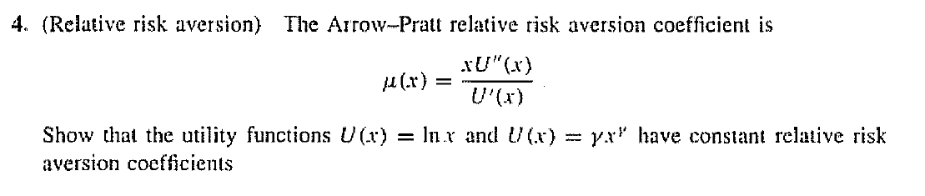
$$1.$$
$$μ\left(x\right)=x·-\frac{1}{x^{2}}·\frac{1}{\frac{1}{x}}=-1$$
2.
$$μ\left(x\right)=x·\frac{\left(α^{2}·\left(α-1\right)·x^{α-2}\right)}{α^{2}·x^{α-1}}=1$$

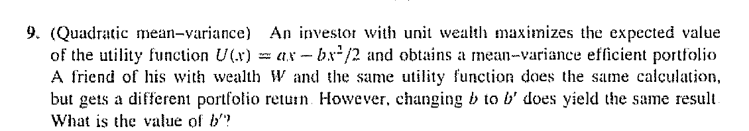

Given mean variance then same return If and only if same risk profile
Thus equivalent with same portfolio
Wealthy persons maximisationproblem
$$\max{E}\left(a·X-\frac{b}{2}X^{2}\right)=\max{E}\left(a·X-\frac{b}{2}{·X}^{2}\right)$$
Poor persons maximisations problem given we want the same portfolio
$$\max{E}\left(a·\frac{X}{w}-\frac{b}{2}{\frac{X}{w^{2}}}^{2}\right)=\frac{1}{w}·\max{E}\left(a·X-\frac{b}{w}{\frac{X}{2}}^{2}\right)=\max{E}\left(a·X-\frac{b^{'}}{2}X^{2}\right)$$
Now simply set $b^{'}=\frac{b}{w}$ and we have an equivalent optimization problem

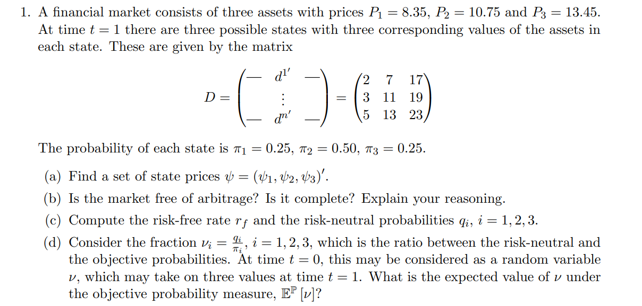
$$D=\left(\begin{matrix}2 & 7 & 17 \\ 3 & 11 & 19 \\ 5 & 13 & 23\end{matrix}\right)$$
$$P=\left(\begin{aligned}8.35 \\ 10.75 \\ 13.45\end{aligned}\right)$$
$$ψ={\left(\begin{matrix}2 & 7 & 17 \\ 3 & 11 & 19 \\ 5 & 13 & 23\end{matrix}\right)}^{-1}\left(\begin{aligned}8.35 \\ 10.75 \\ 13.45\end{aligned}\right)≈\left(\begin{matrix}0,4 \\ 0,35 \\ 0,3\end{matrix}\right)$$
Both arbitrage free and complete since D is invertible
$$ψ_{0}=0.4+0.3+0.35≈1,05$$
$$1.05=\frac{1}{1+x}$$
$⇕$ Ligningen løses for x vha. WordMat.
$$x=-0,04761905$$
$$q=\frac{ψ}{ψ_{0}}=\frac{\left(\begin{matrix}0,4 \\ 0,35 \\ 0,3\end{matrix}\right)}{1.05}≈\left(\begin{matrix}0,3809524 \\ 0,3333333 \\ 0,2857143\end{matrix}\right)$$
$$v=\frac{q}{π}=\left(\begin{aligned}0,3809524·4 \\ 0,3333333·2 \\ 0,2857143·4\end{aligned}\right)≈\left(\begin{matrix}1,52381 \\ 0,6666666 \\ 1,142857\end{matrix}\right)$$
“indgangsvist”
Sum over v med sandsynligheder $π$
$$E^{p}\left[v\right]=1$$
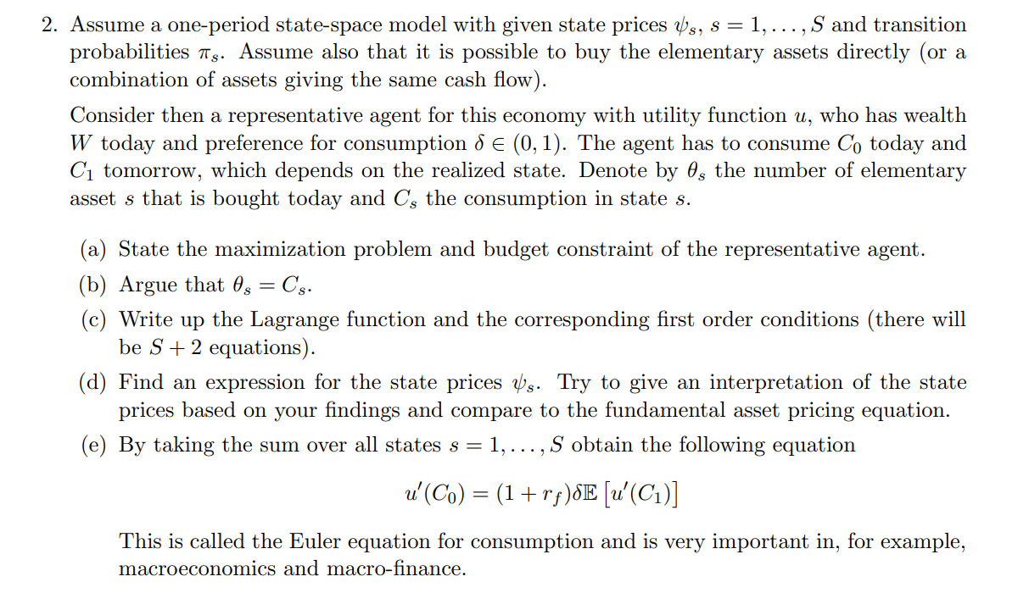
$$\max{U\left(c_{0},c_{1}\right)=U\left(c_{0}\right)+δE\left[U\left(c_{1}\right)\right]}$$
$$c_{0}+\sum_{s=1}^{S}{ψ_{s}·θ_{s}}≤w$$
This comes from the properties of the elementary asset since we bought $θ_{s}$ of the elementary asset s given we reach state s we must have $θ_{s}$ as payout that we defined as $C_{s}$
Write lagrange equations
$$L=U\left(c_{0}\right)+δE\left[U\left(c_{1}\right)\right]-λ\left(c_{0}+\sum_{s=1}^{S}{ψ_{s}·θ_{s}}-w\right)=U\left(c_{0}\right)+δ\sum_{s=1}^{S}{π_{s}U(θ_{s})}-λ\left(c_{0}+\sum_{s=1}^{S}{ψ_{s}·θ_{s}}-w\right)=$$
$$\frac{∂L}{∂c_{0}}=U^{'}\left(c_{0}\right)-λ=0$$
$$\frac{∂L}{∂θ_{i}}=δ·π_{i}·U^{'}\left(θ_{i}\right)-λ·ψ_{s}=0$$
$$Skriv ligningen her.$$
$$c_{0}+\sum_{s=1}^{S}{ψ_{s}·θ_{s}}=w$$
Find an expression of $ψ_{s}$
$$δ·π_{i}·U^{'}\left(θ_{i}\right)=λ·ψ_{s}⇔ψ_{s}=δ·π_{i}·\frac{U^{'}\left(θ_{i}\right)}{λ}=δ·π_{i}·\frac{U^{'}\left(θ_{i}\right)}{U^{'}\left(c_{0}\right)}$$
It how much a person appreciates the expectation of increasing their relative utility
$$\frac{1}{1+r_{f}}=\sum_{s=1}^{S}{ψ_{s}}=\sum_{s=1}^{S}{δ·π_{s}·\frac{U^{'}\left(θ_{s}\right)}{U^{'}\left(c_{0}\right)}}=δ·E\left[\frac{u^{'}\left(C_{1}\right)}{u^{'}\left(c_{0}\right)}\right]$$
$$u^{'}\left(c_{0}\right)=\left(1+r_{f}\right)·δ·E[u\left(C_{1}\right)]$$

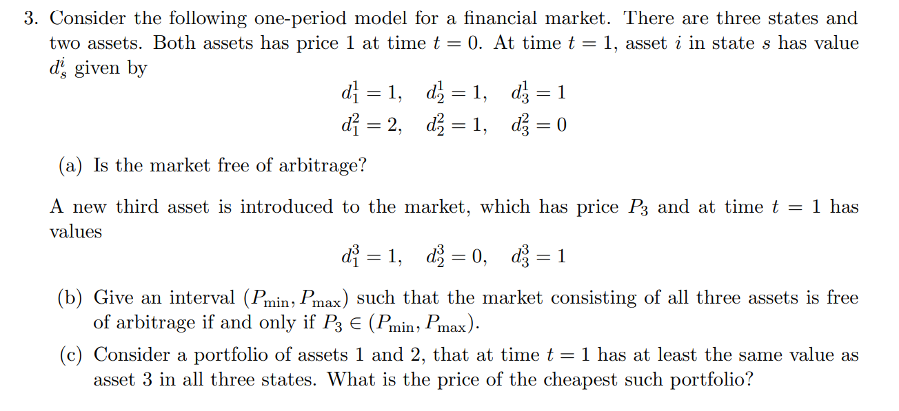
$$D_{1}=\left(\begin{matrix}1 & 1 & 1 \\ 2 & 1 & 0\end{matrix}\right)$$
Is the matret free of arbitrage? Yes
Give a range of the price of an asset with payouts $(\begin{matrix}1 & 0 & 1\end{matrix})$
$$P_{3}∈[0,1]$$
$$D=\left(\begin{matrix}1 & 1 & 1 \\ 2 & 1 & 0 \\ 1 & 0 & 1\end{matrix}\right)$$
$${\left(\begin{matrix}1 & 1 & 1 \\ 2 & 1 & 0 \\ 1 & 0 & 1\end{matrix}\right)}^{-1}\left(\begin{aligned}1 \\ 1 \\ a\end{aligned}\right)=\left(\begin{matrix}\frac{a}{2} \\ 1-a \\ \frac{a}{2}\end{matrix}\right)=ψ≥0⇔a∈[0,1]$$
Its asset 1 if we try to sell asset 2 well have a lesser output in state 1

